MAGENTIX2
USER GUIDE

GTI-IA Research Group

Last update: January 28th, 2010.
Magentix2 version: 1.0

TABLE OF CONTENTS
1 INTRODUCTION 4
2 INSTALLING MAGENTIX2 5
2.1 Getting Magentix2 5
2.2 Pre-requisites 5
2.3 Basic Examples 10
3 CREATING MAGENTIX2 AGENTS 12
3.1 Initialization Tasks 12
3.2 Connecting to the Qpid Broker 13
3.3 Running Agents 14
3.4 Optional Methods 14
3.5 Classes extending BaseAgent 15
4 AGENT COMMUNICATION 16
4.1 FIPA ACL Language 16
4.2 Sending Messages 17
4.3 Receiving Messages 17
4.4 External communication 17
4.5 Using FIPA Protocols 18
5 VIRTUAL ORGANIZATIONS 23
5.1 Overview of THOMAS architecture 23
5.2 Installing Additional Thomas Components 26
5.3 Thomas API 31
5.4 Programming Agents that Offer Services. 37
5.5 Programming Agents that Request Services. 40
6 RUNNING THOMAS EXAMPLE 44
6.1 Initialization Tasks 46

Magentix2: a new open multi-agent system platform.

INTRODUCTION
Multi-agent systems (MAS) are usually very complex systems, where both high-level concepts (such as autonomy, coordination, ...) and low-level techniques (such as code mobility) are involved.
The main goal of the Magentix2 project is to develop a new open multi-agent platform suitable for the development of systems with all these requirements. The features of the Magentix2 platform can be structured in two basic levels, as follows:

- Low-level architecture: this level provides agent communication, interaction protocols and basic agent Java classes. Magentix2 is FIPA compliant and therefore, it can communicate to any other FIPA-compliant platform.

- High-level architecture: this level integrates both multi-agent systems and service-oriented technologies, providing support for virtual organizations. This architecture is called THOMAS (Methods, Techniques and Tools for Open Multi-Agent Systems).

Magentix2 is distributed under the Lesser General Public License (LGPL) http://www.gnu.org/copyleft/lesser.html

INSTALLING MAGENTIX2

Getting Magentix2
Once obtained Magentix2, it must be unzipped. Then, the following files and folders are created:
- Magentix2-1.0-jar-with-dependencies.jar: includes all additional libraries required by Magentix2.
- Magentix2 GNU PGGL License file: license statement of Magentix2.
- Configuration sub-directory: includes the settings.xml and loggin.xml configuration files of Magentix2.
- Examples sub-directory: includes some examples of Magentix2 agent’s implementation.
- Licenses sub-directory: includes license statement terms of all software libraries required by Magentix2.
- Patch file: executable that corrects Qpid source code problems.
- Thomas sub-directory: includes all files required by Thomas. Thomas.sql, sfservices.war, omservices.war and SearchCheapHotel.war
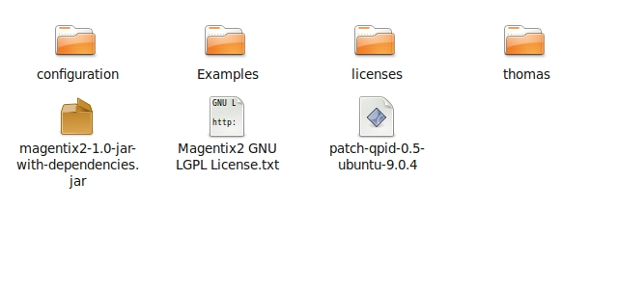

Pre-requisites

Qpid C++ Broker
In this subsection we explain how to install the Qpid/C++ messaging broker, which is the underlying technology used to implement the Magentix2 agent communication. We explain how to build from source in a Ubuntu 9.04 32-bit distribution, but it could be build in any other Linux distribution.

Installing Qpid Dependences
The following libraries must be installed before building the source distribution of Qpid:
- libboost-iostreams 1.35-dev: <http://www.boost.org> (1.35)
- e2fsprogs: <http://e2fsprogs.sourceforge.net/> (1.39)
- pkgconfig: <http://pkgconfig.freedesktop.org/wiki/> (0.21)
- uuid 1.2-1.41.4
- ruby 4.2
- ruby 1.8

On Ubuntu operating system these packages can be installed using the Synaptic package management tool, but any other package manager might be valid. As an example, next figure shows how to install the libboost-iostreams 1.35-dev library.

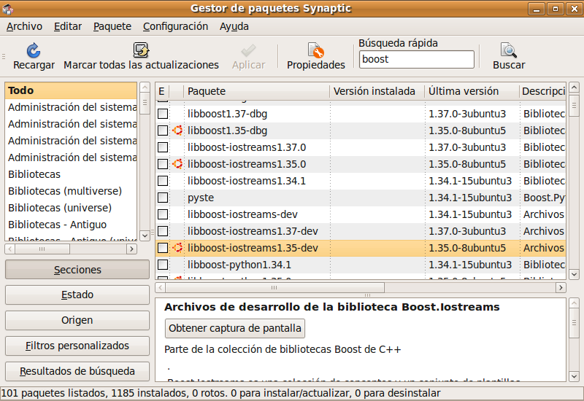

Downloading the Qpid/C++ Broker
We can download the source distribution of Qpid/C++ broker & client 0.5 release from http://qpid.apache.org/download.html:

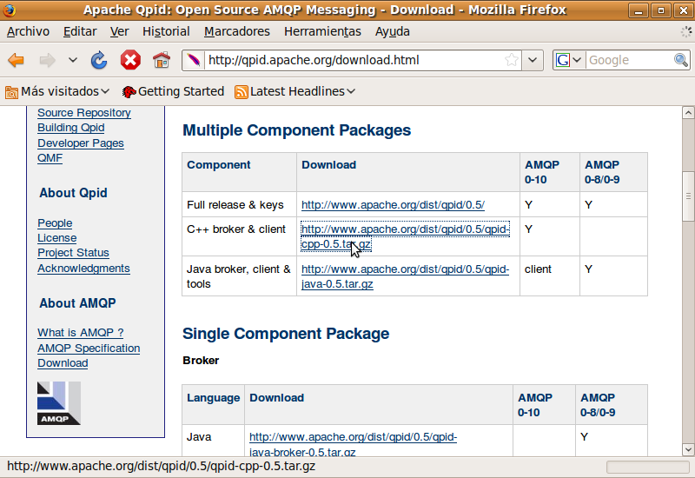

We download the qpid-cpp-05.tar.gz to a folder (for instance /home/hyperion/). Then uncompress using the command:
$ tar xzf qpid-cpp-05.tar.gz
This creates a folder called qpidc-0.5 (In our example /home/hyperion/qpidc-0.5).

Compiling the QPID Broker
To compile and install the Qpid broker, three steps must be performed:
(1) We first configure Qpid:

$ ./configure --prefix= /home/hyperion/qpid
Using the --prefix option when configuring, we can specify where the Qpid binaries are installed (in our case, /home/hyperion/qpid).

(2) Patching the Source Code: In the latest versions of gcc (4.3 and later), some error messages can appear when compiling the Qpid/C++ broker. To solve these errors, we developed a patch included in the Magentix2 distribution, called patch-qpid-0.5-ubuntu-9.0.4. We must run this patch in the folder where we downloaded the Qpid source (in our example /home/hyperion) by executing:

$ sh patch-qpid-0.5-ubuntu-9.0.4

(3) Once the patch is applied, we compile and install qpid by executing:

$ make install

Launching Qpid Broker
We can launch the broker by executing the following command inside the folder where Qpid is installed (in our case, /home/hyperion/qpid):

$ ./qpidd

If the installation and launching process succeeded, the following messages (or similar ones) should appear:

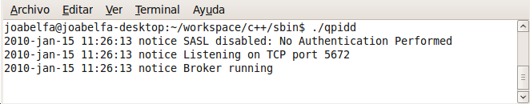

From this moment on, we assume a running instance of the Qpid broker as a requirement to run Magentix2. By default, Qpid is listening to new messages on port 5672.

Java JDK 6
Magentix2 agents are developed in the Java language. Therefore, we must also install the Java virtual machine (version 1.6 and later):

http://java.sun.com/javase/downloads/index.jsp#jdk

ECLIPSE
In this manual we use Eclipse as the Java environment but any other one could be used. Eclipse can be downloaded from:

http://www.eclipse.org/

Configuring Eclipse IDE
If the reader does not know the Eclipse IDE, the following images show how to create a new project and how to add the Magentix2 library to the project.
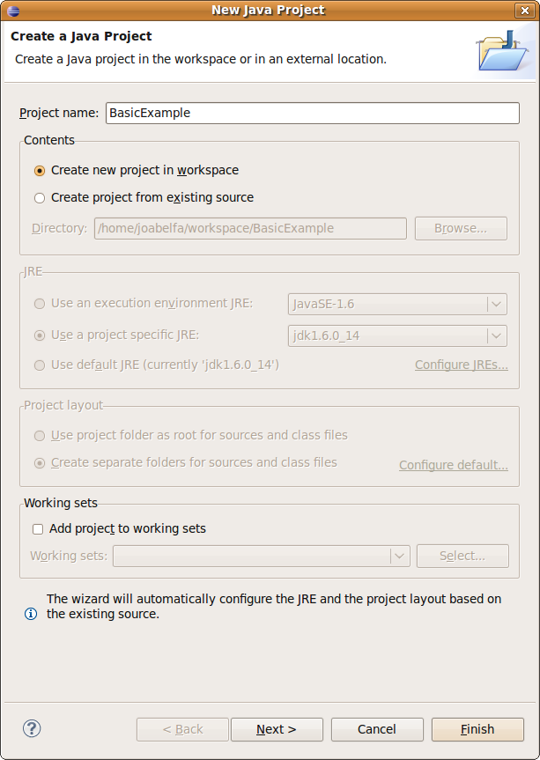

Add Magentix2.jar dependence

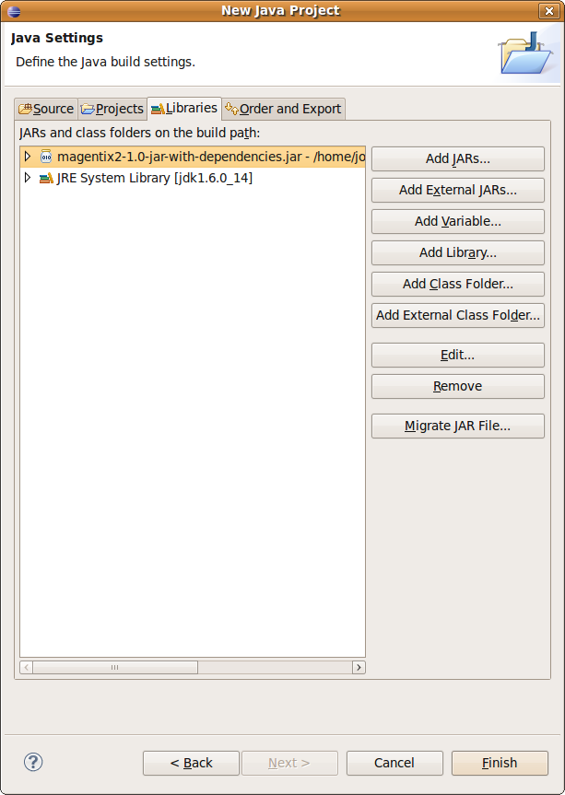

Finally we must copy the configuration folder from the Magentix2 package to the main folder of the project:

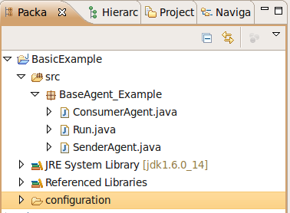

Now, we are able to develop agents in Magentix2 platform.

Basic Examples

Description
In the examples folder of the Magentix2 packages there are some basic examples of agents:
- BaseAgent: this is an example of sender/consumer agents. The sender agent sends an ACLMessage to the consumer agent. When the ACLMessage arrives to the consumer agents, a message is shown.
- BridgeAgent: this is an example in which an internal agent sends a message to an external agent of the platform.
- Request: this example follows the FIPA Request protocol. In this example two agents are created. One agent plays the responding role by simulating a hospital which listens emergency calls. The other agent simulates an accident witness. When the witness see an accident sends a help message to the hospital. The hospital checks if the accident is placed in the action area and if it could attend it.
- ContractNet: this is an example the FIPA ContractNet protocol is followed. In this example, two kind of agents are created. One kind of agents plays the responding role (dealers). The other kind is the initiator role (buyer), played by a single agent. The buyer sends a purchase request to each dealer agent. Each dealer agent answers the bid according her preferences and waits for the buyer decition. The buyer chooses one offer and informs the specific dealer and also sends a reject message to the rest of the dealers.
- Thomas: This is an example of two agents (client and provider). These agents compose the travelagency organizational unit. The provider agent offers two services: searchs for touristic information and booking hotels. The client agent uses the SF and the OMS services in order to interact with the provider agent.

Content

The examples folder includes:
- “Magentix2_Example.jar”: compiled code required to run the examples.
- “/examples_source_code” folder: the source code of the examples.
- ”*.bat files”: for running the examples in Windows.
- ”*.sh files”: for running the examples in Linux.
- “/logs” folder: default log4j exit.
- “/configuration” folder: includes the settings.xml and the logs.xml configuration files of the Magentix2 platform.

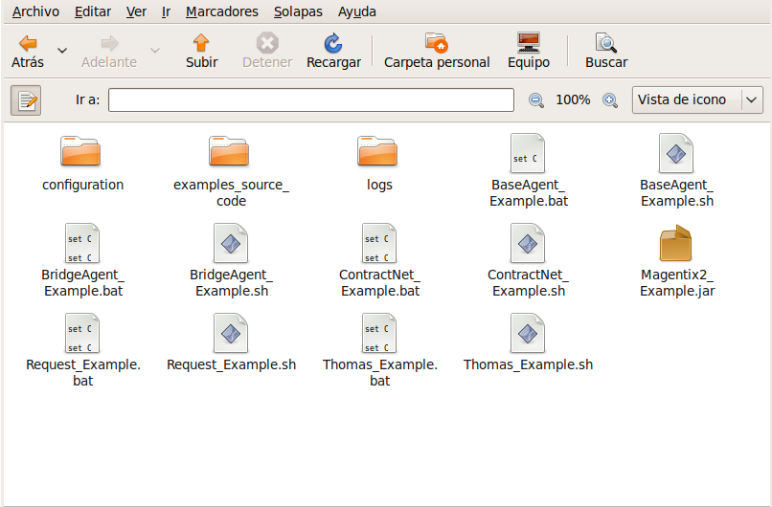

CREATING MAGENTIX2 AGENTS
To create a Magentix2 agent we must define a class which extends the es.upv.dsic.gti_ia.core.BaseAgent class. We must associate a unique identifier (AgentID) to the agent and implement the logic of the agent in the execute() method.

import es.upv.dsic.gti_ia.core.ACLMessage;
import es.upv.dsic.gti_ia.core.AgentID;
import es.upv.dsic.gti_ia.core.BaseAgent;

public class SenderAgent extends BaseAgent {

public SenderAgent(AgentID aid) throws Exception {
super(aid);
}

public void execute() {
System.out.println("Executing, I'm " + getName());

}

}

Initialization Tasks
Our platform uses log4j as a logging facility. It was developed by the Apache's Jakarta Project. It's speed and flexibility allows log statements to remain in shipped code while giving the user the ability to enable logging at runtime without modifying any of the application binary.
Log4j must be initialized inside the main() method of each Java application as follows:

DOMConfigurator.configure("configuration/loggin.xml");

Logger logger = Logger.getLogger(Run.class);

The file logging.xml is used to specify what level of log messages are written to the log files for each component. Moreover, Log4j allows logging requests to print to multiple destinations called appenders. Two types of appenders have been defined for Magentix2. You can also define the following types of appenders when required: GUI components, remote socket servers, JMS, NT Event Loggers, and remote UNIX Syslog daemons.

Appender 1
<appender name="File" class="org.apache.log4j.FileAppender">
<param name="File" value="logs/Magentix2.log"/>
<layout class="org.apache.log4j.PatternLayout">
<param name="ConversionPattern" value="%t %-5p %c{2} - %m%n"/>
</layout>
</appender>

Appender 2
<appender name="Console" class="org.apache.log4j.ConsoleAppender">
<layout class="org.apache.log4j.PatternLayout">
<param name="ConversionPattern" value="%d %-5p [%t] %C{2} (%F:%L) - %m%n"/>
</layout>
</appender>

The first appender indicates a file as the standard output and the second one indicates the console as the standard output. To learn more refer to: http://logging.apache.org/log4j/1.2/index.html

Connecting to the Qpid Broker
A connection to the Qpid broker must be established before launching any agent. This connection will be used by agents to communicate to each other. Remember that, at this point, we assume that you have a Qpid broker installed and running properly.
The following parameters must be specified in any connection to the broker:
- <QpidHost> indicates the machine where Qpid is running.
- <QpidPort> refers to the port where Qpid is listening to.
- <QpidVhost> is a path which acts as a namespace.
- <QpdidUser> user name to access Qpid.
- <QpidPassword> password to access Qpid.
- <QpidSSL> indicates if SSL is used during the connection.

There are three different ways to establish a connection to the Qpid broker using the connect() method implemented in the es.upv.dsic.gti_ia.core.AgentsConnection class:

- Calling connect() without parameters. Then, the parameters are gathered from the Settings.xml file.

Example: AgentsConnection.connect();

We can specify the connection parameters inside the Settings.xml file. Note that if you do not specify all the parameters in the Settings.xml file, you should not use the connect() method without parameters.
An example of the Settings.xml file would be:

<!-- Properties qpid broker -->
<entry key="host">localhost</entry>
<entry key="port">5672</entry>
<entry key="vhost">test</entry>
<entry key="user">guest</entry>
<entry key="pass">guest</entry>
<entry key="ssl">false</entry>

- Specifying all the parameters when calling connect().

Example: AgentsConnection.connect(localhost, 5672,"test","guest","guest",false);

- Specifying only the <qpidhost> parameter, leaving the rest as default parameters.

Example: AgentsConnection.connect("gtiiaprojects2.dsic.upv.es");

Running Agents
Once agents are implemented, they can be instantiated and launched. (Please note that the platform do not allow several agents with the same name.)

In order to instantiate an agent, and agent ID must be also created as follows:
- AgentID(String Identifier), where Identifier is the agent name.

Examples of creating a new instantiation:

SenderAgent agent1 = new SenderAgent(new AgentID("sender"));

ConsumerAgent agent2 = new ConsumerAgent(new AgentID("consumer"));

Once Instantiated, agents can be launched by calling to their start() method.

Examples:
agent1.start();
agent2.start();

Optional Methods
The init() and finalize() methods are also defined in the es.upv.dsic.gti_ia.core.BaseAgent class. These methods are automatically executed before and after the execute() method. The programmer can overload these methods in order to include initialization or termination tasks.

Classes extending BaseAgent
All the agents implemented on top of Magentix2 must be defined extending the BaseAgent class or one of its subclasses. As examples of subclasses of the BaseAgent class we find the following:

- es.upv.dsic.gti_ia.architecture.QueueAgent defines an new agent class, extending of BaseAgent. This type of agent implements a set of protocols. QueueAgent class is explained in the 2.4 subsection.
- es.upv.dsic.gti_ia.core.SingleAgent defines an new agent class, extending BaseAgent. It defines a new message reception method (receiveACLMessage()) that performs blocking reception.

AGENT COMMUNICATION

Agent communication is a crucial feature to support the sociability skills of agents. Indeed, this feature plays a crucial role in the success of an intelligent agent platform.
In Magentix2, each agent has a message queue on the Qpid broker, where other agents can post messages addressed to her.
The following figure illustrates how a sender agent posts a message in a queue. Then, a consumer agent is able to read this message.

FIPA ACL Language
Messages exchanged by Magentix2 agents have the format specified by the ACL language defined by the FIPA (http://www.fipa.org) international standard for agent interoperability. This format comprises a number of fields, such as:

- The sender of the message.
- A list of receivers.
- The performative: REQUEST, INFORM, QUERY_IF, CFP, PROPOSE, ACCEPT_PROPOSAL, REJECT_PROPOSAL, etc.
- The content.
- The content language.
- The content ontology.
- The conversation-id, reply-with, in-reply-to, reply-by, etc.

A message in Magentix2 is implemented as an instance of the es.upv.dsic.gti_ia.core.ACLMessage class that provides get and set methods for handling all the fields of a message.

Sending Messages
For sending a message to another agent the programmer must fill the fields of an ACLMessage object and then calling the send() method of the es.upv.dsic.gti_ia.core.BaseAgent class.

The code below informs an agent whose identifier is receiver with the text "Hello I'm sender".

// Building a ACLMessage
ACLMessage msg = new ACLMessage(ACLMessage.REQUEST);
msg.setReceiver(receiver);
msg.setSender(this.getAid());
msg.setLanguage("ACL");
msg.setContent("Hello, I'm " + getName());

// Sending a ACLMessage
send(msg);

Receiving Messages
Whenever a message is posted in the message queue of an agent, this agent is notified by the onMessage(ACLMessage msg) method. This method allows agents to receive any message automatically. Note that agents can also keep all received messages in an internal list (or queue) for reading them later.
Agent programmers must redefine this when implementing a new agent, so that when the agent receives a message, it can be read. For instance:

public void onMessage(ACLMessage msg) {

// When a message arrives, it is shown in the screen

logger.info("Mensaje received in " + this.getName() + " agent, by onMessage: " + msg.getContent());
}

External communication
External agents are any agent not running on top of Magentix2 but communicating to any of the agents running on Magentix2. In this sense, Magentix2 implements the FIPA-HTTP message transport protocol by means of two special Magentix2 agents:
- es.upv.dsic.gti_ia.core.BridgeAgentInOut receives all the messages in which the recipient is an agent running on another platform (protocol = http). Then, the BridgeAgentInOut encapsulates the entire message and sends the message via http.
- es.upv.dsic.gti_ia.core.BridgeAgentOutIn routes messages from external agents (received via http) to internal agents. Therefore, BridgeAgentOutIn decodes the http message received and creates an ACLMessage message. After that, BridgeAgentOutIn sends the new created message to the recipient's mailbox.

These agents are not launched by default, and must be instantiated and launched to allow external communication.

External agents are identified (to send messages to them) by means of an http address that must be used when creating the corresponding AgentID. For instance:

new AgentID("http://peter@mymachine:8080")

Using FIPA Protocols
Magentix2 also supports the set of interaction protocols defined by FIPA. Thereby, agents can communicate to each other by means of different protocols explained in this section.
Each implemented protocol provides the basic message exchange between two agents for a given type of conversation (a request, a query, etc.). In order to implement these protocols, we have defined a new agent template called QueueAgent. This template extends BaseAgent and can be found in package es.upv.dsic.gti_ia.architecture. The following figure shows a UML class diagram for the QueueAgent class.
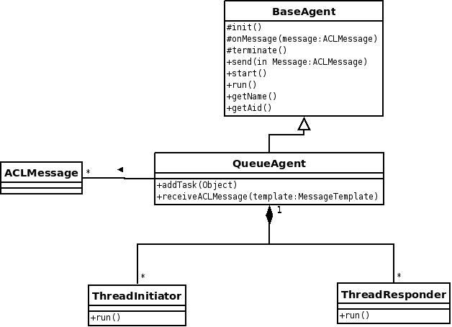

UML Model of the QueueAgent

In order for agents to use protocols, they must extend the QueueAgent class and redefine its constructor. For instance:

import es.upv.dsic.gti_ia.architecture.QueueAgent;
import es.upv.dsic.gti_ia.core.AgentID;

public class agent extends QueueAgent {

public agent(AgentID aid) throws Exception {
super(aid);
}

Communication Protocols on Magentix2 platform.
Three interaction protocols specified by FIPA (Request, Query and the Contract-Net) have been implemented. For this purpose, a set of classes have been implemented, and they can be found into the es.upv.dsic.gti-ia.architecture package.
Within all of the protocols implemented, agents can play both initiator and responder role. These roles implement different behaviors. The initiators are executed once, while responders are executed cyclically, so they will return to its initial state after reaching the final one.
The set of classes in the es.upv.dsic.gti-ia.architecture package have been designed so that programmers do not need to deal with neither message sending nor protocol status monitoring. Thus, programmers only have to define what should be done in each state of the protocol and prepare messages before sending. The actions performed in each state are defined by handlers for initiator roles and preparers for responder roles.

Handlers:
A handler is a method which is executed when a specific protocol state is reached for agents playing initiator roles. Each protocol has a handler per each state it can reach. Although there are default handlers (which do nothing) defined for each protocol, agent programmers can overload each handler with the functionality they require in each protocol state.

protected void handleAgree(ACLMessage agree) {
logger.info("Good news");
}

Preparers:
Preparers are similar to handlers but are executed when the agent plays the responder role in the protocol.
Messages must be filled in very careful because leaving a field empty can interrupt the entire protocol. Therefore, we encourage the use of the method createReply() included in ACLMessage messages. This method produces a new answer to the original message with the required fields covered so that only required ones need to be modified.

protected ACLMessage prepareResultNotification(ACLMessage inmsg, ACLMessage outmsg) {

ACLMessage msg = inmsg.createReply();
return (msg);
}

How to implement a FIPA-Protocol

FIPA-Request
This protocol allows agents to request other agents to perform an action and it is identified in the protocol parameter of the message with the FIPA-request value. The messages exchanged are:
- Request, the request .
- Agree, if the agent accepts the request or Refuse if she rejects it.
- If the previous message is an Agree: Failure if an error happened in the process, Inform-done if it was successful and Inform-result if it was successful and there is a result.
The protocol early terminates if:
- The initiator send to the responder a message explicitly CANCEL instead of the next initiator.
- The responder responded negatively to REFUSE, NOT_UNDERSTOOD or FAILURE.

Role responder:

public class Responder extends FIPARequestResponder {

public Responder(QueueAgent agent) {
super(agent,new MessageTemplate(InteractionProtocol.FIPA_REQUEST));

}

protected ACLMessage prepareResponse(ACLMessage msg) {
protected ACLMessage prepareResultNotification
(ACLMessage inmsg, ACLMessage outmsg) {}
Role initiator:

class Initiator extends FIPARequestInitiator {

public Initiator(QueueAgent a, ACLMessage msg) {
super(a, msg);
}

protected void handleAgree(ACLMessage agree) {
protected void handleRefuse(ACLMessage refuse) {
protected void handleNotUnderstood(ACLMessage notUnderstood) {
protected void handleInform(ACLMessage inform) {
protected void handleFailure(ACLMessage failure) {

FIPA-Query
This protocol allows agents to request other agents: to query whether a particular proposition is true or false (query-if) and to query for some identified objects (query-ref). Depending on the type of request the messages can be:

- Query-If o Query-Ref, the request.
- Agree if the agent accepts the request or refuse if she rejects it.
- If accepted:Failure if an error occurred in the process,Inform-T/F with the response if the request was a Query-If or Inform-Result if the request was a Query-Ref.

Packages classes:
es.upv.dsic.gti-ia.architecture.FIPAQueryResponder
es.upv.dsic.gti-ia.architecture.FIPAQueryInitiator

FIPA-Contract-Net
The classes ContractNet implemented the behaviour of the protocol of the same name, whose operation is that the initiator sends a proposal to several responders, evaluate their answers and choose the preferred one (or no one). The messages exchanged are:
- CFP (Call For Proposal), specifying the action to carry out and, if appropriate, the conditions on the performance.
- The responders can send a Refuse to reject their participation, a Not-Understood if there were failings in communication or a Propose with the proposal to the initiator.
- The initiator evaluates all proposals received and sent Reject-Proposal to reject or Accept-Proposal to accept them.
- Responders whose proposal was accepted send a Failure if something went wrong, an Inform-Done if the action was performed successfully or Inform-Results with the results of the operation if necessary .

The initiator (ContractNetInitiator) has two main methods, the handlePropose that is called each time a response is received and the handleAllResponses that is called when all responses are received or the timeout is exceeded. The responder agent has handleAcceptProposal and handleRejectProposal methods, which are called depending on whether the proposal was accepted or not, and their main characteristic is that both of them receive as parameters all the messages exchanged so far by both agents.

Packages classes:
es.upv.dsic.gti-ia.architecture.FIPAContractNetResponder
es.upv.dsic.gti-ia.architecture.FIPAContractNetInitiator

Running QueueAgents
Once defined the protocol, we have to create a new instance and add it to the agent tasks (method addTask). In the initiator role, we have to create and fill in the appropriate message for the desired protocol.

For example, for the protocol request:

ACLMessage msg = new ACLMessage(ACLMessage.REQUEST);
msg.setReceiver(new AgentID("HospitalAgent"));
msg.setProtocol(InteractionProtocol.FIPA_REQUEST);
msg.setContent("accident to " + "10" + " km");
msg.setSender(this.getAid());

this.addTask(new FIPARequestInitiator(this,msg));

For the responder, we have to create a template with the desired protocol:

MessageTemplate plantilla = new MessageTemplate(
InteractionProtocol.FIPA_REQUEST);

this.addTask(new FIPARequestResponder(this,plantilla));

When we add a task, a new thread is created for the agent. Therefore, we must be careful that the main thread of the agent is not finished. For instance, a monitor can be used to wait for the completion of the roles:

import es.upv.dsic.gti_ia.architecture.Monitor;

private Monitor monitor = new Monitor();

protected void execute() {
.
.
.
this.addTask(new FIPARequestInitiator(this, msg));
monitor.waiting();
}

VIRTUAL ORGANIZATIONS
As it has been pointed out in the introduction, Magentix2 platform not only has as aims to provide a guaranteed communication mechanism to the programmer, but also to provide a complete support for virtual organizations. THOMAS (Methods, Techniques and Tools for Open Multi-Agent Systems) framework has been integrated with Magentx2 with this purpose.

Overview of THOMAS architecture
Recently, several works have appeared that try to solve the problem of integrating the multi-agent system paradigm and the service-oriented computing paradigm. Both paradigms try to offer solutions for the development of complex and adaptive systems in distributed open environments. In this line, integrating these technologies is possible to model autonomous and heterogeneous computational entities in dynamic and open environments.
The proposed solution tries to communicate agents and web services in a transparent, but independent, way. Agents can offer and invoke services in a transparent way to other agents or entities, as well as external entities can interact with our agents through the use of the offered services. THOMAS architecture consists of a set of modular services. Agents have access to the infrastructure offered by THOMAS through a set of services including on two main components:

- Service Facilitator (SF), this component offers simple and complex services to the active agents and organizations. Basically, its functionality is like a yellow page service and a service descriptor in charge of providing a green page service.

- Organization Manager Service (OMS), it is mainly responsible of the management of the organizations and their entities. Thus, it allows the creation and the management of any organization, the roles the agents play and the norms that rule their behavior.

Service Facilitator
The SF is a mechanism and support used by organizations and agents to offer and discover services. The SF provides an environment in which the autonomous entities can register service descriptions as directory entries.
The SF acts as a gateway to access the THOMAS platform. The SF can find services searching for a given service profile or searching by the goals that can be fulfilled executing the service. This is done using the matchmaking and service composition mechanisms that are provided by the SF.
The SF also acts as a yellow pages manager and in this way it can also find which entities provide a given service. Services may have some pre-conditions that have to be true before the service can be executed. They exchange one or more input and output messages. A successful service execution has some effects on its environment. This parameters are called IOPE (input/output/preconditions/effects). Moreover, there could be additional parameters, which are independent of the service functionality (non-functional parameters), such as quality of service, deadlines, and security protocols among others.

Finally, the results of the service can be enhanced using automatic service composition mechanisms (for example, partial matchmaking). To do this, the SF maintains the description of the internal processes that are executed when the service is running.

A service represents an interaction between two entities, which are modelled as communications among independent processes. In our case, the Multi-agent Technology provides us with FIPA communication protocols.

Taking into account that we are dealing with semantic services, another important data is the ontology used in the service. When the service description is accessed, any entity has all the needed information available to interact with the service.

The set of services provided by the SF to manage the services of the platform (meta-services) are classified in 3 categories:

- Registration: they allow adding, modifying and removing services from the SF directory (RegisterProfile, RegisterProcess, ModifyProfile, ModifyProcess).
- Affordability: for managing the association between providers and their services (AddProvider, RemoveProvider).
- Discovery: for searching and composing services as an answer to user requirements (SearchService, GetProfile, GetProcess).

Organization Manager Service
This component is in charge of organizations life cycle management, including specification and administration of their structural components (roles, organizative units and norms) and their execution components (participant agents and the roles they play; and active units in each moment). OMS offers all services needed for a suitable organization performance. These services are classified as:
- Structural services, that modify the structural and normative organization specification;
- Dynamical services, that allow agents to entry or leave the organization dynamically, as well as role adoption.

By means of the publication of the structural services, OMS allows modifying, in execution time, some aspects related to the organization structure, functionality or normativity. Some of these services should be restricted to internal roles of the system, which have enough permission to do this kind of operations (i.e. a supervisor role). Dynamic services manage the creation/registration of new agents in the organization, entry or exit of unit members and role adoption. These services are always published in the SF.

The OMS provides agents with a set of services for organization life-cycle management, classified in:

- Structural services, which modify the structural and normative organization specification, i.e. roles, norms and organizational units (RegisterRole, DeregisterRole, RegisterNorm, De-registerNorm,RegisterUnit,DeregisterUnit).
- Informative services, that give information of the current state of the organization (InformUnitRoles, InformAgentRoles, InformMembers, InformQuantity, InformUnit, InformRoleProfiles, InformRoleNorms).
- Dynamic services, that allow managing role enactment and dynamic entry/exit of agents (AcquireRole, LeaveRole,Expulse).[1]

To sum up, the next figure shows the structure of the THOMAS framework:

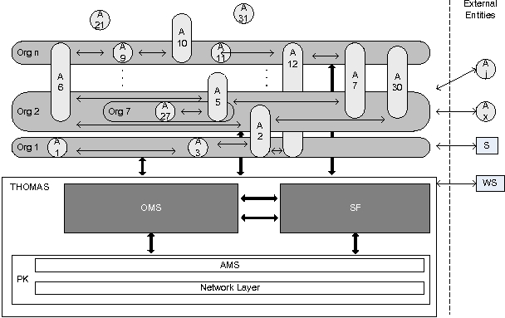
Thomas Architecture

Installing Additional Thomas Components
In this section, we specify all the additional components required to run a Thomas framework and how they must be configured. Required packages can be found in the Thomas subdirectory within the zip file or you can download them by yourself

Tomcat 6.0
http://tomcat.apache.org/tomcat-6.0-doc/deployer-howto.html#Installation

MySQL (http://www.mysql.com/)

Thomas platform Is based on services, so SF and OMS service implementation have to be available as standard web services. This is also applied to any other user service (such as the application examples).

Copy packaged libraries of Thomas (omsservices.war, sfservices.war) and also the Thomas examples (SearchCheapHotel.war) from Magentix2 distribution to the subdirectory webapss of Tomcat. After that, start Tomcat by running the startup.sh file on the /bin subdirectory of Tomcat.

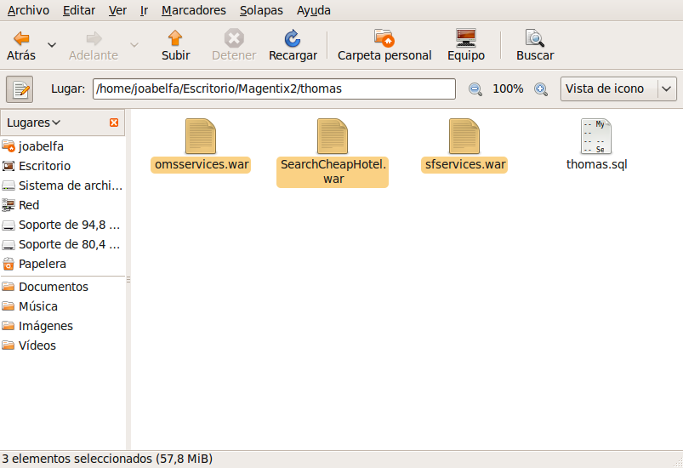
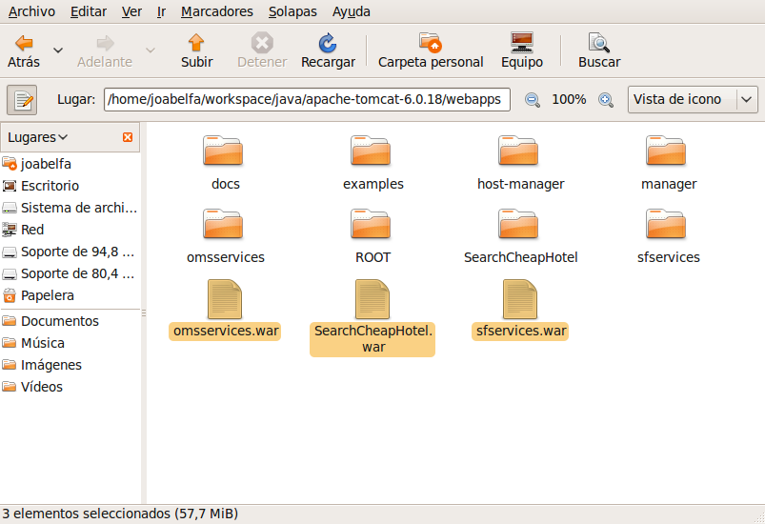
Location of Thomas web sevices files (*.war)

All the information about the running platform is permanently stored in a database. The complete structure of the database is available in the “Thomas.sql” file, which has to be loaded in a MySQL database.

Open the MySQL Administrator and select Restore Backup option, as illustrated in the next image, and select Thomas.sql file. Remember that this file is in Thomas sub-directory:

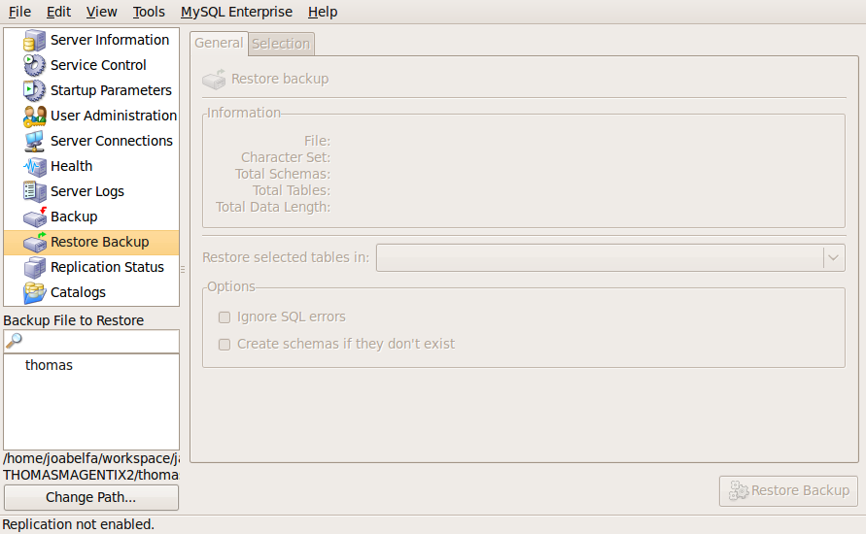

Add a new user to Thomas Schema as follows:

User=”thomas”
Password= “thomas”

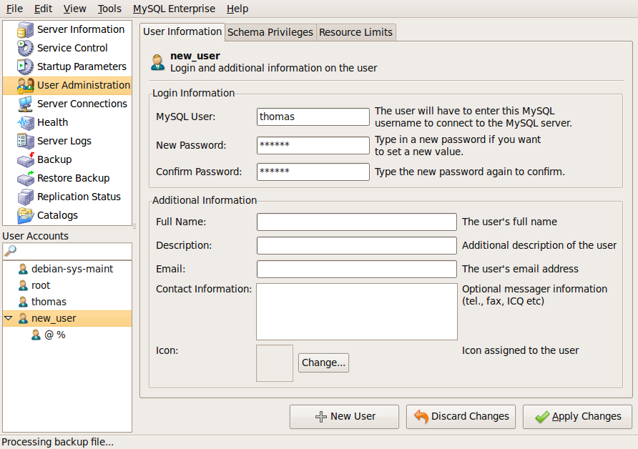
These values also must be configured on the settings.xml file of Magentix2:

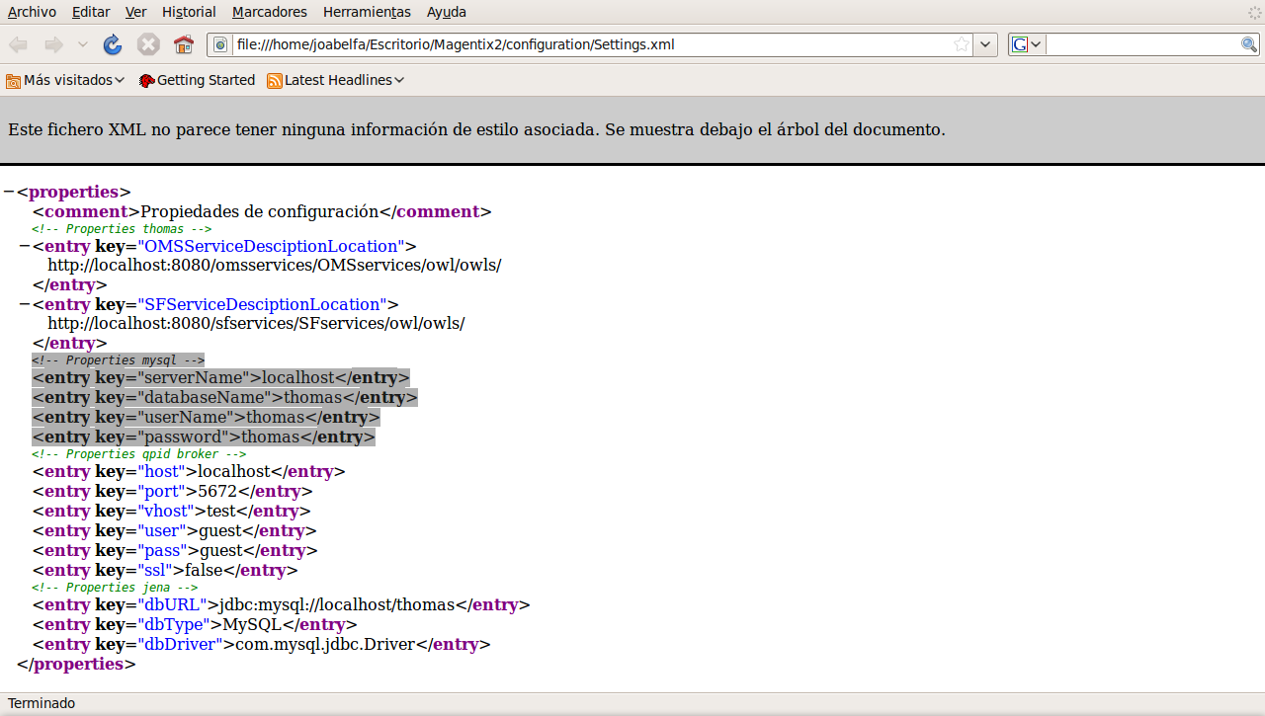
Finally, available privileges for all tables of Thomas must be assigned to this user:

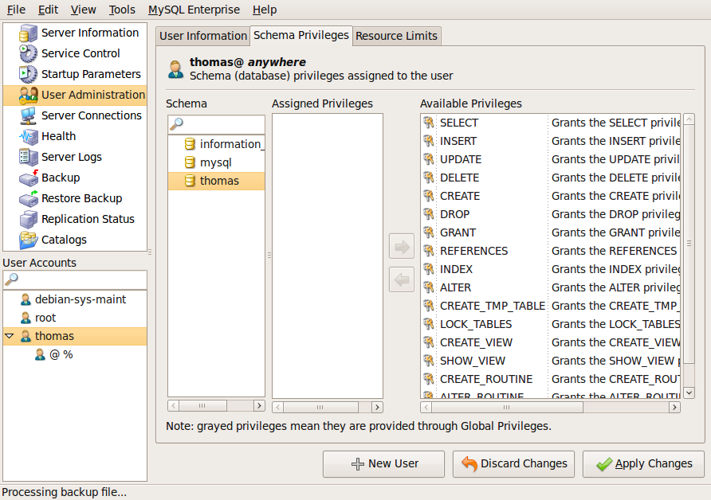

Thomas API
SF and OMS have been defined as two types of intermediary agents in order to address the translation between Magentix2 agents (or any external agent), that implement FIPA communication,and the services they provide. Services requests through FIPA-request protocol were received by this type of agents.

To ease the interaction among user agents and OMS and SF agents, two classes are provided (OMSProxy and SFProxy). They work as a proxy for OMS and SF respectively, encapsulating and hiding the details of the underlying communication protocol. By doing this, the developer can interact with OMS and SF using simple function calls.

OMSProxy
The OMSProxy can be found in the package es.upv.dsic.gti_ia.organization. To use its functionality, a new instance of the OMSProxy class must be created to access the methods contained in the OMS. In the constructor, the url where OMS services are deployed (.war) can be specified
private OMSProxy omsProxy = new OMSProxy("url");

or it can be empty if the route will be taken from the settings.xml configuration file [6.1] (recommended option).
private OMSProxy omsProxy = new OMSProxy();

OMSProxy provides the developer with a set of methods to manage available services, as Table 1 shows:

Type | Subtype | OMS-Service | Description
Structural | Registration  Information | RegisterRole  RegisterNorm  RegisterUnit  DeregisterRole  DeregisterNorm  DeregisterUnit  InformAgentRole  InformMembers  QuantityMembers  InformUnit  InformUnitRoles  InformRoleProfiles  InformRoleNorms | Creates a new role within a unit  Includes a new norm within a unit  Creates a new unit within a specific organization  Removes a specific role description from a unit  Removes a specific norm description  Removes a unit from an organization  Indicates roles adopted by an agent  Indicates entities that are members of a specific unit  Provides the number of current members of a specific unit  Provides unit description  Indicates which roles are the ones defined within a specific unit  Indicates all profiles associated to a specific role  Provides all norms addressed to a specific role
Dynamic | Compound | AcquireRole  LeaveRole  Expulse | Requests the adoption of a specific role within a unit  Requests to leave a role  Forces an agent to leave a specific role
Table 1. OMS services

All these methods return a status indicating whether the operation was successful or not. Exceptions must be handled.
try {
omsProxy.acquireRole(this, "member", "virtual");
} catch (Exception e) {
logger.error(e.getMessage());

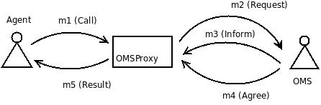

Interaction between user agent and OMS agent through the OMSProxy

SFProxy
The SFProxy we can find inside the package es.upv.dsic.gti_ia.organization. To use its functionality, a new instance of the SFProxy class must be created to access the methods contained in the SF. In the constructor, the url where SF services are deployed (.war) can be specified

private SFProxy sfProxy = new SFProxy("url");
or it can be empty if the route will be taken from the settings.xml configuration file [6.1] (recommended option).

private SFProxy sfProxy = new SFProxy();

SFProxy provides the developer with a set of methods to manage available services, as Table 2 shows:
Type | SF-service | Descriptión
Registration | RegisterProfile  RegisterProcess  ModifyProfile  ModifyProcess  DeregisterProfile | Creates a new service description (profile)  Creates a particular implementation (process) for a service  Modifies an existing service profile  Modifies an existing service process  Removes a service description
Affordab. | RemoveProvider | Removes a provider from a service
Discovery | SearchService  GetProfile  GetProcess | Searches a service (or a composition of services) that satisfies the user requirements  Gets the description (profile) of a specific a service  Gets the implementation (process) of a specific a service
Table 2. SF services
All these methods return a status indicating whether the operation was successful or not. Exceptions must be handled.
try {
results=sfProxy.searchService(this,"SearchCheapHotel");
}
} catch (Exception e) {
logger.error(e.getMessage());
}
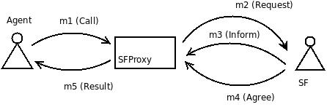
Interaction between user agent and SF agent through the SFProxy

Basic Service Management

Services are composed by a profile, which is a semantic description of the service, useful for customers to locate appropriate service, and a process, which details how to interact with the service.

Different agents can provide different processes (different implementations) to the same service profile (general description), so profiles and services are kept separately. Some templates which can adequately fill in all required fields in a profile (ProfileDescription) and process (ProcessDescription) have been created.

The ProfileDescription can be found inside the package es.upv.dsic.gti_ia.organization. This template contains all methods and variables needed for the proper configuration of a profile. The most important slots are:

ServiceID
Is generated automatically by the database. It's a numeric value.
URLProfile
The url where the profile document (OWL-S) is located.
Serviceprofile
It is a url which makes reference to the service profile description document.

Profile name
Name to the service profile description document.

When an agent needs to register a new profile in the organization, the RegisterProfile method of the SFProxy class is invoked. The following code shows how to create a new profile and register it in the organization.

import es.upv.dsic.gti_ia.organization.SFProfileDescription;
ProfileDescription profile = new ProfileDescription( "URLProfile","SearchCheapHotel");
try {
sfProxy.registerProfile(this, profile);
} catch (Exception e) {
logger.error(e.getMessage());
}
The ProcessDescription is included in the es.upv.dsic.gti_ia.organization package

In contains all the methods and variables needed for the proper configuration of a process. The most important slots are:

ServiceID
The service profile id is a number generated automatically by the sf database.

Implementation ID
Is the id of the service implementation. It is composed of: serviceid@serviceprocessid-agentid.

URLProcess
The URL where the process owl document is located.

Servicemodel
It is a url which makes reference to the service process description document.

Process name
Name to the service process description document.

An agent can register its own implementation of an existing profile or create a new service from the scratch. In the latter case, the profile and the process must be specified. The following code shows how register a new implementation (process) for an existing profile:

import es.upv.dsic.gti_ia.organization.SFProcessDescription;

ProcessDescription process = new ProcessDescription( "URLProcess","SearchCheapHotel");
try
{
results = sfProxy.searchService(this, "SearchCheapHotel");
process.setProfileID(results.get(0));
sfProxy.registerProcess(this, process);
}catch (Exception e) {
logger.error(e.getMessage());
}

Oracle: extracting information from OWL-S

The oracle is class that allows developers to parse the profile of a semantic service, specified in OWL-S, in order to extract the required information, such as service inputs, outputs, list of roles or organizational units.

Oracle needs just the url of the OWL-S file containing the service profile to analyze it (as a parameter in the constructor of the class, see the example). This url can be obtained with the method getProfile() of SFPRoxy class.

Once we have the profile, the oracle can be asked about any field in the profile information. The available methods for the Oracle class can be found in the Javadoc documentation of the project.

import java.net.URL;
import es.upv.dsic.gti_ia.organization.Oracle;
private Oracle oracle;
//get the profile information
String URLProfile = sfProxy.getProfile(this, results.get(0));
URL profile;
//load in the oracle the profile and parse it
try {
profile = new URL(URLProfile);
oracle = new Oracle(profile);
} catch (MalformedURLException e) {
logger.error("ERROR: Profile URL Malformed!");
e.printStackTrace();
}
//access to the profile information through the oracle
oracle.getProviderList();

Programming Agents that Offer Services.
This section describes how an agent that offers services to the other agents inside the organization can register, announce and provide its services.

Register and Acquire Role.
- Registration of an agent on the platform Thomas. The agents request to be registered as a member of a Thomas platform using the AcquireRole() service:

try {
omsProxy.acquireRole(this, "member", "virtual");
} catch (Exception e) {
logger.error(e.getMessage());
}
- Registering a new provider. Once the agent is registered, it can use public services offered by the OMS and SF. The provider agent requests to the SF the list of services that have been registered in the platform using a profile similar to the “search cheap hotels” service:

results=sfProxy.searchService(this, "SearchCheapHotel");

If there is some service that meets the description, the provider agent uses the getProfile() service to retrieve the service profile information:

String URLProfile = sfProxy.getProfile(this, results.get(0));

The SF responds with the URI where the service profile description are located. The ProviderAgent analyzes the profile of service. It indicates that any provider of the service must adopt the Provider role inside the unit TravelAgency.:

URL profile;
try {
profile = new URL(URLProfile);
oracle = new Oracle(profile);

} catch (MalformedURLException e) {
logger.error("ERROR: Profile URL Malformed!");
e.printStackTrace();
}
omsProxy.acquireRole(this,oracle.getProviderList().get(0), oracle.getProviderUnitList().get(0));

Service Registration
- Registering a new implementation of a service. In this case, the provider agent want to register its own service implementation SearchCheapHotel. To do this, a new process for the SearchCheapHotel profile must be created and registered in the organization (using RegisterProcess()). The proccessDescription must have the ID of profile which associate the process (returned by the method searchService()).

try {
processDescription.setProfileID(results.get(0));
sfProxy.registerProcess(this, processDescription);
} catch (Exception e) {
logger.error(e.getMessage());
}

Execution of a Service (mindswap)
For the execution of the service, we use the Mindswap API. This API offers an execution engine for OWL-S specifications. The execute()method allows to execute directly a semantic service description in OWL-S. This method has two input parameters, a process description (Process) and a value map (ValueMap) with the values of all input parameters of any elemental service included in the service in execution.

The methods getProcess() and getServicerequestValues() allow the developer to get the process and the set of input values for any elemental service involved in the execution.

import org.mindswap.owls.OWLSFactory;
import org.mindswap.owls.process.Process;
import org.mindswap.owls.process.execution.ProcessExecutionEngine;
import org.mindswap.query.ValueMap;

// create an execution engine
ProcessExecutionEngine exec = OWLSFactory.createExecutionEngine();

try {
Process aProcess = processDescription.getProcess(inmsg);

// gwts the input values for the services
ValueMap values = new ValueMap();
values = processDescription.getServiceRequestValues(inmsg);
//executes the service
values = exec.execute(aProcess, values);
} catch (Exception e) {
e.printStackTrace();
}

Programming Agents that Request Services.
This section describes how an agent that requires services from other agents belonging the organization can search and request services.

Register and Acquire Role.
- Registration of an agent on the platform Thomas. The agents request to register as members of the Thomas platform using the AdquireRole() service:

try {
omsProxy.acquireRole(this, "member", "virtual");
} catch (Exception e) {
logger.error(e.getMessage());
}

Service Search Process.
- Search of a service. Once the agent is registered, it can use the SearchService() service to find required services. The agent obtains a more detailed information of the service in which it is interested from the profile service, obtained with the getProfile() service. In that description, the agents realizes that it is necessary to play the Customer role, so the agents request it. Finally, when all this goals are accomplished, the agent can get the detailed information about the service and how to use it invoking the GetProcess() service.

try {
result = omsProxy.acquireRole(this, "member", "virtual");
do {
results = sfProxy.searchService(this, "SearchCheapHotel");
} while (results.size() == 0);
URLProfile = sfProxy.getProfile(this, results.get(0));
URL profile;
try {
profile = new URL(URLProfile);
oracle = new Oracle(profile);
} catch (MalformedURLException e) {
logger.error("ERROR: Profile URL Malformed!");
e.printStackTrace();
}
OMSservices.acquireRole(this,oracle.getClientList().get(0), oracle.getClientUnitList().get(0));
agents = sfProxyv.getProcess(this, results.get(0));
} catch (Exception e) {
logger.error(e.getMessage()); }

Service Request Process.
- Request a service. After the agent has analysed the implementation details of the service (the process), it can contact with the agent supplier and ask for the service (SearchCheapHotel) to the locate a hotel in the desired city. The genericService() is used with this purpose

try {
ArrayList<String> arg = new ArrayList<String>();
int i = 0;
for (String input : oracle.getInputs()) {
switch (i) {
case 0:
System.out.println("Input: " + input);
arg.add("5");
break;
case 1:
System.out.println("Input: " + input);
arg.add("Spain");
break;
case 2:
System.out.println("Input: " + input);
arg.add("Valencia");
break;
}//switch
i++;
}//for
Enumeration<AgentID> agents1 = agents.keys();
AgentID agentToSend = agents1.nextElement();
URLProcess = agents.get(agentToSend);
// call the service SearchCheapHotel
list=SFservices.genericService(this,agentToSend,URLProfile,
URLProcess, arg);
Enumeration<String> e = list.keys();
while (e.hasMoreElements()) {
String key = e.nextElement();
System.out.println(" " + key + " = " + list.get(key));
}//while
} catch (Exception e) {
logger.error(e.getMessage());
} //try-catch

Thomas Platform Initialization and Execution

The process to create, initialize and run a Thomas platform is the following:
- connect with the qpid broker
- create and launch OSM and SF internal agents
- create and launch any user agent

The following code shows how to create the platform and launch the required agents in the travel agency example

AgentPayee payeeAgent;
AgentProvider providerAgent;
AgentAnnouncement registerAgent;
AgentClient clientAgent;

// Clean database
CleanBD clean = new CleanBD();

clean.clean_database();

// Connecting to Qpid Broker, default localhost.
AgentsConnection.connect();

try {

// Instantiating a OMS and FS agent's
OMS agenteOMS = OMS.getOMS();
agenteOMS.start();

SF agenteSF = SF.getSF();
agenteSF.start();

// Execute the agents
payeeAgent = new AgentPayee(new AgentID("agentPayee"));

providerAgent = new AgentProvider(new AgentID("providerAgent"));

registerAgent = new AgentAnnouncement(new AgentID("registerAgent"));

clientAgent = new AgentClient(new AgentID("clientAgent"));

registerAgent.start();
payeeAgent.start();

Monitor m = new Monitor();
m.waiting(10 * 1000);
providerAgent.start();
m.waiting(10 * 1000);
clientAgent.start();

} catch (Exception e) {
logger.error(e.getMessage());

}

Between executions, OMS and SF agents must be stopped and the Tomcat server reset. Furthermore, to avoid problems with old services inside internal Thomas and Jena tables, the database must be cleaned. To do this, a CleanDB class is provided. You must clean the database prior to any execution.

import es.upv.dsic.gti_ia.organization.CleanBD;

CleanBD clean = new CleanBD();
clean.clean_database();

RUNNING THOMAS EXAMPLE
The Thomas package includes the travel agency example complete. All these examples we can find in the distributable zip, inside the section examples Thomas. Execute the Thomas_Example script (.sh or .bat) to run the example

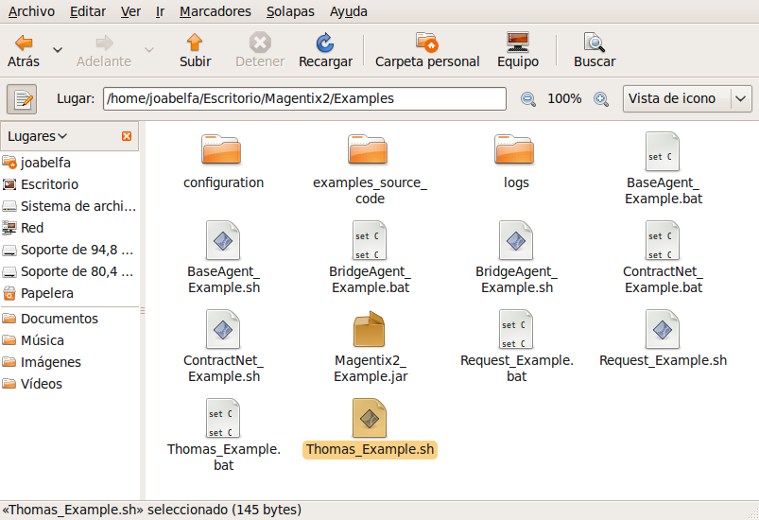

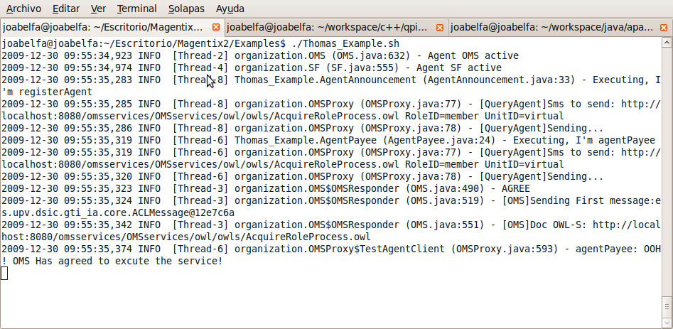
The distribution of all the agents in the example and the technologies used by them are shown in the following graph.
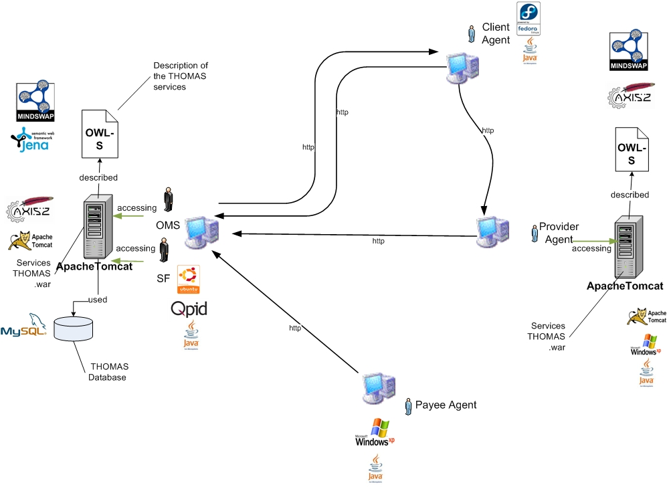
Complete scheme of the example TravelAgency

OMS and SF agents use Jena and Mysql to manage internally all the required information about services and organizations. Mindswap API is used by any provider agent to execute semantic descriptions of services. Services are deployed using Apache Tomcat as container for the servlets. The examples have been tested successfully on PC's with Ubuntu, Fedora and Windows xp.

Initialization Tasks
Finally, we will explain how to specify parameters for Thomas and Jena and Thomas database via a configuration file settings.xml. Remember that there are only two configuration files, loggin.xml and settings.xml.

OWL properties indicates where the services are deployed (in the file is set to localhost by default). This infromaytion is used by the OMSProxy and the SFProxy.

<!-- Properties thomas -->
<entry key="OMSServiceDesciptionLocation">http://localhost:8080/omsservices/OMSservices/owl/owls/</entry>
<entry key="SFServiceDesciptionLocation">http://localhost:8080/sfservices/SFservices/owl/owls/</entry>

Furthermore, the file includes information about the mysql databases used by Thomas and Jena for the persistence of information between executions

<!-- Properties mysql -->
<entry key="serverName">localhost</entry>
<entry key="databaseName">thomas</entry>
<entry key="userName">thomas</entry>
<entry key="password">thomas</entry>

<!-- Properties jena -->
<entry key="dbURL">jdbc:mysql://localhost/thomas</entry>
<entry key="dbType">MySQL</entry>
<entry key="dbDriver">com.mysql.jdbc.Driver</entry>

Please, check that the data contained in the settings.xml file fulfils with the actual settings for the existing databases.

References
1 E. del Val , N. Criado , M. Rebollo , E. Argente and V. Julian.: Service-Oriented Framework for Virtual Organizations

Qpid has been built using the GNU C++ compiler: gcc <http://gcc.gnu.org/> (3.4.6).
Earlier versions of boost e.g. 1.33 also work and there is a patch to get 1.32 working in the svn tree though that is only recommended as a last resort.
For UNIX Systems the corresponding “*.sh” files are required
http://www.mindswap.org/
http://jena.sourceforge.net/
http://www.mysql.com/
http://www.mindswap.org/
http://tomcat.apache.org/
http://www.ubuntu.com/
http://fedoraproject.org/es/
http://www.microsoft.com/latam/windowsxp/default.mspx

